**Full Stack Development with MERN**

**Frontend Development Report**

|  |  |
| --- | --- |
| Date | 11 July 2024 |
| Team ID | SWTID1720010842 |
| Project Name | Book a Doctor |
| Maximum Marks | 10 Marks |

**Project Title: Book a Doctor**

Date: 11-07-24

Prepared by: Swathie P, Jaiganesh S, V Kavya Sahithi, Maturi Nikhitha

**Objective**

The objective of this report is to document the frontend development progress and key aspects of the user interface implementation for the Book a Doctor project.

**Technologies Used**

* **Frontend Framework:** React.js
* **State Management:** Redux
* **UI Framework/Libraries:** Material-UI, Bootstrap
* **API Libraries:** Axios

**Project Structure**

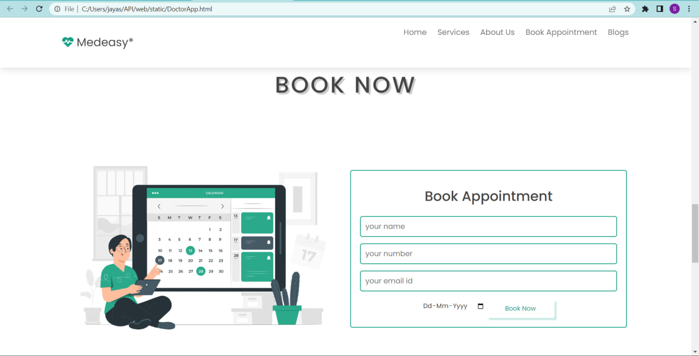

**Key Components**

1. **App.js**
   * Responsible for routing and main application layout.
2. **/components**
   * Contains reusable UI components used across the application.
3. **/pages**
   * Includes different pages for Web App.

**Routing**

Routing is managed using React Router. Here are the main routes:

* **/home** - Landing page of the application.
* **/dashboard** - Dashboard displaying user data and statistics.
* **/profile** - User profile management.

**Integration with Backend**

The frontend communicates with the backend APIs hosted on `https://backend.bookadoctor.com` Key endpoints include:

* **GET /api/data** - Retrieves data for display.
* **POST /api/user/login** - Handles user authentication.

**User Interface (UI) Design**

* The UI design follows a modern, user-friendly design principles with a focus on simplicity and ease of use.
* Implemented using Material-UI and Bootstrap for consistent and responsive design.

**Third-Party Integrations**

* Axios: For making HTTP requests to the backend.
* Material-UI: For building responsive and customizable UI components.
* React Router: For handling routing in the application.